Dương Chí Khang – 1822040036

Bài tập tuần 11

Controller TheLoai

namespace Baitaptuan6_2.Controllers

{

public class TheLoaiController : Controller

{

private readonly ApplicationDbContext _db;

public TheLoaiController(ApplicationDbContext db)

{

_db = db;

}

public IActionResult Index()

{

var theloai = _db.TheLoai.ToList();

ViewBag.TheLoai = theloai;

return View();

}

[HttpGet]

public IActionResult Create()

{

return View();

}

[HttpPost]

public IActionResult Create(TheLoai theloai)

{

if (ModelState.IsValid)

{

//xử lý việc tạo mới

_db.TheLoai.Add(theloai);

_db.SaveChanges();

return RedirectToAction("Index");

}

return View();

}

[HttpGet]

public IActionResult Edit(int id)

{

if (id == 0)

{

return NotFound();

}

var theloai= _db.TheLoai.Find();

return View();

}

[HttpPost]

public IActionResult Edit(TheLoai theloai)

{

if (ModelState.IsValid)

{

//xử lý việc tạo mới

_db.TheLoai.Update(theloai);

_db.SaveChanges();

return RedirectToAction("Index");

}

return View();

}

[HttpGet]

public IActionResult Delete(int id)

{

if (id == 0)

{

return NotFound();

}

var theloai = _db.TheLoai.Find(id);

return View();

}

[HttpPost]

public IActionResult DeleteConfirm(int id)

{

var theloai = _db.TheLoai.Find(id);

if (theloai == null)

{

return NotFound();

}

_db.TheLoai.Remove(theloai);

_db.SaveChanges();

return RedirectToAction("Index");

}

}

}

Index TheLoai

@{

ViewData["Title"] = "Index";

// Layout = "";

}

<h1>Các Thể Loại</h1>

<div class="container">

<table class="table">

<**a** **asp-controller**="TheLoai" **asp-action**="Create" class="btn btn-primary">Thêm mới</**a**>

<thead>

<tr>

<th>Tên thể loại</th>

<th>Ngày tạo</th>

<th>Chức năng</th>

</tr>

</thead>

<tbody>

@foreach (var item in @ViewBag.TheLoai)

{

<tr>

<td width="30%">@item.Name</td>

<td width="70%">@String.Format("{0:dd/MM/yyyy}", item.DateCreated)</td>

<td width="40%">

<**a** **asp-action**="Edit" **asp-route-id**="@item.ID">Edit</**a**> | <**a** **asp-action**="Delete" **asp-route-id**="@item.ID">Delete</**a**>

</td>

</tr>

}

</tbody>

</table>

</div>

Create TheLoai

@{

ViewData["Title"] = "Create";

}

@model TheLoai

<div class="container">

<**form** method="post">

<**div** **asp-validation-summary**="All" class="text-danger"></**div**>

<h3>Thêm thể loại</h3>

<div class="form-group">

<**label** **asp-for**="Name">Tên thể loại</**label**>

<**input** **asp-for**="Name" **type**="text" class="form-control" />

<**span** **asp-validation-for**="Name" class="text-danger"></**span**>

</div>

<div class="form-group">

<**label** **asp-for**="DateCreated">Ngày tạo</**label**>

<**input** **asp-for**="DateCreated" **type**="date" class="form-control" />

<**span** **asp-validation-for**="DateCreated"></**span**>

</div>

<button type="submit" class="btn btn-primary">Lưu</button>

</**form**>

</div>

@section Scripts {

<**partial** **name**="_ValidationScriptsPartial" />

}

Edit TheLoai

@{

ViewData["Title"] = "Edit";

}

@model TheLoai

<div class="container">

<**form** method="post" **asp-action**="Edit">

<**div** **asp-validation-summary**="All" class="text-danger"></**div**>

<h3>Chỉnh sửa thể loại</h3>

<div class="form-group">

<**label** **asp-for**="Name">Tên thể loại</**label**>

<**input** **asp-for**="Name" **type**="text" class="form-control" />

<**span** **asp-validation-for**="Name" class="text-danger"></**span**>

</div>

<div class="form-group">

<**label** **asp-for**="DateCreated">Ngày tạo</**label**>

<**input** **asp-for**="DateCreated" **type**="date" class="form-control" />

<**span** **asp-validation-for**="DateCreated"></**span**>

</div>

<button type="submit" class="btn btn-primary">Lưu</button>

<**a** **asp-action**="Index" class="btn-btn-secondary">Huỷ</**a**>

</**form**>

</div>

@section Scripts {

<**partial** **name**="_ValidationScriptsPartial" />

}

Delete TheLoai

@{

ViewData["Title"] = "Delete";

}

@model TheLoai

<div class="container">

<h3>Xoá thể loại</h3>

<**form** method="post" **asp-action**="DeleteConfirm">

<**input** **asp-for**="ID" **type**="hidden"/>

<**div** **asp-validation-summary**="All" class="text-danger"></**div**>

<div class="form-group">

<**label** **asp-for**="Name">Tên thể loại</**label**>

<**input** **asp-for**="Name" **type**="text" class="form-control" />

<**span** **asp-validation-for**="Name" class="text-danger"></**span**>

</div>

<div class="form-group">

<**label** **asp-for**="DateCreated">Ngày tạo</**label**>

<**input** **asp-for**="DateCreated" **type**="date" class="form-control" />

<**span** **asp-validation-for**="DateCreated"></**span**>

</div>

<button type="submit" class="btn btn-primary">Lưu</button>

<**a** **asp-action**="Index" class="btn-btn-secondary">Huỷ</**a**>

</**form**>

</div>

@section Scripts {

<**partial** **name**="_ValidationScriptsPartial" />

}

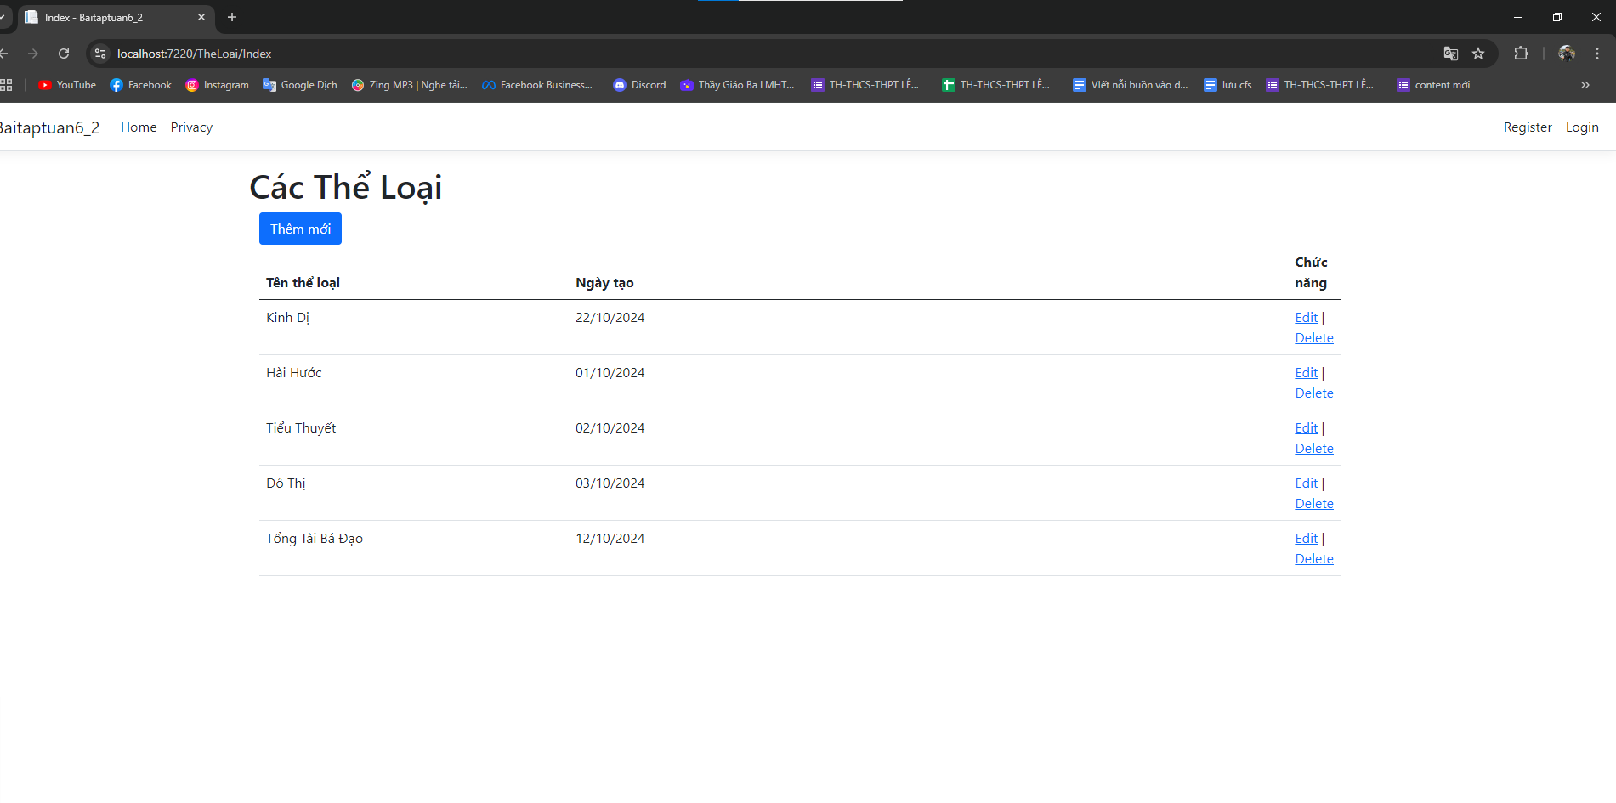Kết Quả

